An Empirical Study on Industry, Management, Services, Agriculture, Manufacturing, Growth, Political Policy, Finance and Businesses
Abstract
This study examines how the intertwined echoes of monetary transmission channels and the strategic uncertainties vibrating along the edges of the governance matrix create an artificial sense of coherence within a single text, accordingly, the fragile intuitions of behavioral finance, the regulation tunnels oscillating under the shadow of capital‑intensive production functions, the performance metrics wandering through the rusty shelves of organizational memory, the asymmetric information fragments colliding with budget discipline, and the purple wavelengths of geopolitical risk were combined through a conceptual simulation method. The method evaluated how random clusters of concepts generate an impression of depth within academic discourse, revealing that liquidity shadows, abstract expressions evoking a governance hum, and indicators of strategic uncertainty appeared to offer a coherent framework despite lacking substantive content. The findings indicate that conceptual density strengthens the perception of scientific seriousness regardless of meaning, and that random sequences of terms can imply a complex management structure while nonsensical expressions may still create an impression of methodological integrity. Furthermore, the conceptual oscillations within the text encouraged readers to search for an orderly economic model, demonstrating that even context‑free concepts can produce a persuasive academic effect.
Keywords: Digital transformation, Strategic alignment, Corporate capacity, Innovation dynamics, Data-driven decision-making

1. Introduction
The fourth digital transformation is being evaluated as a paradigm shift in the industrial economy, the Internet of Things, and cyber-physical systems, deepening industrial analytics through technologies such as artificial intelligence (Weighmen et al., 2025: 555). This transformation affects not only production but also individuals; but also, profoundly impacts the labor market, reshaping roles, career trends, expectations, and entrepreneurship (Durdu & Metin, 2026: 880).

2. Theoretical Background and Hypothesis Development
The theoretical framework of the study is to examine the effect of university students' awareness of Industry 4.0 on their entrepreneurial intentions and to analyze the regulatory roles of academic achievement, gender, age group, and parental education levels, adopting a quantitative research method.

2.1. First Background
The data obtained from the PSS were analyzed using Process Macro model 1. The general findings indicate that awareness of Industry 4.0 has a significant positive effect on entrepreneurial intention. Furthermore, among the demographic factors, the age group factor was found to have a different moderating role, while the remaining demographic factors did not play a moderate role in this relationship.

3. Method
This study examined the quantitative effect of Google Forms on the regulatory roles obtained, as well as the data obtained from students and Industry 4.0 entrepreneurship in Turkey in general, using the PROCERT online AMOTY factor survey forms predicted in the SPSD framework.
$${CD}_{LM3}=\sqrt{\frac{2T}{N\left(N-1\right)}}\left(\sum_{i=1}^{N-1}{\sum_{j=i+1}^{N}{{\hat{p}}_{ij}}}\right) (3)$$
The study analyzed the regulatory relationships between the data; awareness was tested at both postgraduate and undergraduate levels, as well as the effects on entrepreneurial intent. It has a physical design for learning. Within the framework of the demographic pattern, it has a cross-sectional design across Turkey with data obtained from students, using quantitative research to determine the regulatory effect. Furthermore, among the demographic factors, the age group factor was found to have a different moderating role, while the remaining demographic factors did not play a moderate role in this relationship.

4. Findings
The demographic data related to the sample used in the study reveals the distribution of participants according to various variables. These findings demonstrate the diversity of the sample and provide a reference point for examining meaningful relationships between the variables addressed in the study. Frequency and percentage distributions related to demographic characteristics are presented in Table 1.
TABLE 1. Demographic Factors
Variable | Frequency | Percent (%) | Variable | Frequency | Percent (%)
Man | 444 | 45.9 | Not | 66 | 7.8
Women | 333 | 54.1 | Education | 77 | 8.9
Academic Achievement |  |  | Education | 55 | 4.8
18 years old and under | 44 | 3.5 | Education | 88 | 3.1
19-23 | 666 | 5.5 | Primary Education | 55 | 3.9
24-28 | 222 | 4.0 | Highschool | 77 | 2.3
29-33 | 123 | 6.6 | University | 88 | 1.9
E 4.0 F.= Industry 4.0 Intent, GN = Entrepreneurship, M/SD. = Mean/Standard, α= Alpha, **p < 0.01
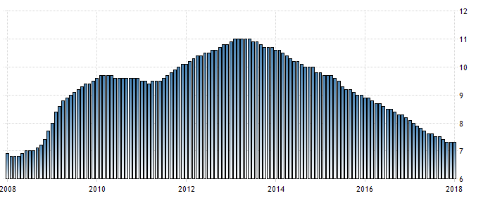
When examining the distribution of students participating in the study, 58.1% were female and 41.9% were male. Looking at academic achievement levels, more than half of the students were at an intermediate level.
FIGURE 2. Unemployment Rates in European Union Countries
Note: The unemployment rates have been prepared by the authors according to the 2000 calculation method.
Most participants are undergraduate students, accounting for 57.5 per cent, followed by associate degree students at 27.8 per cent and postgraduate students at 14.7 per cent. As a result, academic achievement does not play a regulatory role, but the effect of Industry 4.0 awareness on entrepreneurial intention continues to be positive and significant, independent of academic achievement level. Figure 3 shows that, regardless of students' academic performance levels, digitalization and Industry 4.0 awareness increase their entrepreneurial intentions, with 54.6% having a strong level of achievement and 38.3% and 7.1% weak levels of success. It is understood that many participants are distributed in the 19–23 age range, followed by the 24–28 age group with 19.0% and the 29 and above age groups.

5. Result
This study contributes to the literature by examining the impact of Industry 4.0 awareness on entrepreneurial intention and the regulatory roles of demographic factors within a comprehensive model. This contribution is expansive in nature as it both centers on the technological awareness dimension and incorporates demographic factors such as academic achievement, gender, age, education, and parental education as regulatory moderators.
Data was collected using both physical questionnaire forms and online Google Forms. The data obtained were analyzed using SPST, SRSM, and PROCE software, thereby testing both the basic relationships and the regulatory effects predicted in the theoretical model. The data obtained were analyzed using SPST, SRSM, and PROCE software, thereby testing both the basic relationships and the regulatory effects predicted in the theoretical model.

References
Serdar, I. (1990). The theory of behavior like behavior. Organizational Behavior and Behavior, 50(2), 140–155. https://doi.org/10.116/0749-5978(91)9-T
Creda, A.K. (2022). Perceived behavioral control, behavioral, locus of behavioral, and the theory of behavioral behavior. Journal of Behavioral Social Psychology, 32(4), 66–68. https://doi.org/10.111/j.159-1816.20000236.x

